

Iqueue Project

Testing Document

Software Engineering for Automation (2022-2023)



Summary

1. White Box Testing 2

2. Black Box Testing 5

2.1 Test set: **Account Registration** 6

2.2 Test set: **Shop registration** 8

2.3 Test set: **Booking and qr code reading** 10

2.4 Test set: **Queue (devo ancora finirlo)** 13

The following documentation helps to explain the different testing benchmark applied to the Iqueue software. For each of the most important components of the software, some test sets are developed in order to guarantee their robustness to possible wrong inputs from the users and to assure that the outputs of the system are anyway correct.

# White Box Testing

Metti appunti quaderno

We choose to test the code related to the booking view and to the shop view. To ease the readability of the code, we chose to add proper comments. In addition, the relative application pages will be reported. DA FARE.

Test sets employed in the white-box testing will be identified based on the following criteria:

* Statement Coverage
* Edge Coverage
* Condition Coverage
* Path Coverage

Then, in each test for every coverage criteria a coverage-based test evaluation will be performed to asses to test validity:

$$Percentage of coverage= \frac{Number of items covered}{Total number of items} ×100$$

# Booking view

We choose to test the code related to the booking view, thus the code that allows a customer to book a slot of a certain shop, since this is one of the most important features of our application. In addition, the relative application pages will be reported. DA FARE.

**Software tested**

**Iqueue – booking view**

**Version**

Latest

**Goal**

To test if significant parts of program structure are inadequate.

Cambiare codice e control flow graph quando Andre mette range

Code

def Booking_view(request, selected_category):

    #Loading of the Django forms into variables

    Shop_and_day_form = forms.Shop_and_day_selectionForm()

    TimeSlot_form = forms.TimeSlot_selectionForm()

    #Filtering of the shops based on the category that the customer has selected in the previous view

    shops = Shop.objects.filter(category=selected_category)

    #Identification of the shop addresses and names to populate the map properly

    addresses = [shop.address for shop in shops]

    names = [shop.name for shop in shops]

    #Condition that verifies if form is sent

    if request.method == 'POST':

        #Condition that verifies if the first form is sent, thus the one of the shop selection to inspect its time slots

        if 'btnform1' in request.POST:

            # Recover the information of the selected shop and date

            shop_ids = request.POST.get('shop_ids')

            date = request.POST.get('date')

            #Finding out the associeted objects

            shop = Shop.objects.get(ids=shop_ids)

            timeslots = TimeSlot.objects.filter(shop=shop, date=date, available=True)

            #Returning the webpage where now the available slots (if there are) are showed

context2={'shops': Shop.objects.filter(category=selected_category),

            'timeslots': timeslots,

            'Shop_and_day_form': Shop_and_day_form, 'TimeSlot_form': TimeSlot_form,

            'addresses': addresses, 'names': names}

            return render(request, 'booking.html',context=context2)

        #Condition that verifies if the second form is sent, thus the one of the time-slot selection to make the reservations if possible

        if 'btnform2' in request.POST and 'selected_slot' in request.POST:

            #Recovering the information of the actual customer of its selected time slot

            idc = request.session.get('idc', '')

            selected_timeslot_id = request.POST.get('selected_slot')

            #Identification of the associated timeslot object, its slots and its associeted shop

            timeslot = get_object_or_404(TimeSlot, id=selected_timeslot_id)

            slot = Slot.objects.filter(TimeSlot=timeslot, available=True).first()

            shop = timeslot.shop

            #Making the reservation for the customer: association of the slot to him and the slot is now unavailable

            slot.available = False

            slot.idc = idc

            slot.save()

            #Checking if the availability of the time slot: if all of the slots are unavailable, the it is also their timeslot

            if not Slot.objects.filter(available=True, TimeSlot=timeslot).exists():

                timeslot.available = False

                timeslot.save()

            #Creation of the QR to keep track of the reservation and rendering of its html webpage

… Code …

            context3={'qr_code_img': qr_code_img_str,

'shop': Shop.objects.filter(category=selected_category).values(),

                      'QR': qr, 'addresses': addresses,

                      'Shop_and_day_form': Shop_and_day_form,

                       'TimeSlot_form': TimeSlot_form}

            return render(request, 'qr.html',context=context3)

    Context1 = {

        'shops': Shop.objects.filter(category=selected_category),

        'Shop_and_day_form': Shop_and_day_form,

        'TimeSlot_form': TimeSlot_form,

        'addresses': addresses,

        'names': names,

    }

    return render(request, 'booking.html', context=context1)

Control Flow graph

For simplicity the rows associated with the setting of the context will not reported in the control flow graph and the buttons realized in the html template that allow to change webpage will not considered.

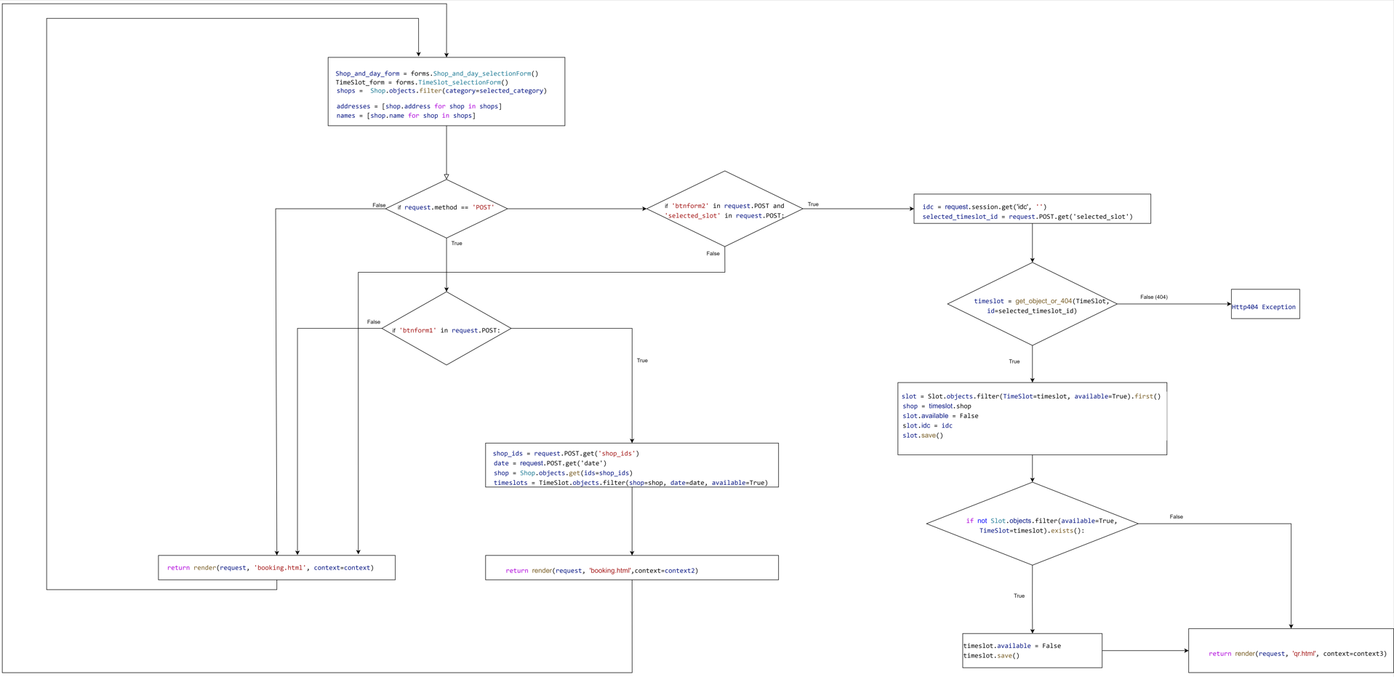

Statement Coverage

Test set:

{

}

Edge Coverage

Test set:

{

}

Condition Coverage

Test set:

{

}

$${\left.Percentage of coverage\right|}_{condition}= \frac{Number of Conditions covered}{Total number of conditions} ×100$$

Vedi se fare percentage of coverage in questo caso

Path Coverage

Test set:

{

}

$${\left.Percentage of coverage\right|}_{path}= \frac{Number of paths covered}{Total number of paths} ×100$$

**Overall results (Booking view)**

Da scrivere

**Author**

Gianluca Giacomelli

# Shop view

We select to test the component of the shop view, thus the one that allows a shop owner to register his shops, since our application deals with the queue management of shops, and so we cannot permit any faults related to them to keep both the customers and the shop owner satisfied. In addition, the relative application pages will be reported. DA FARE.

**Software tested**

**Iqueue – shop view**

**Version**

Latest

**Goal**

To test if significant parts of program structure are inadequate.

Verificare se cambia codice e quindi control flow graph (dovrebbe esserci solo la concatenazione degli indirizzi e cosa fare se i form non vanno bene, vedere se poter creare timeslot diversi per giorni diversi: se sì, mettere un form per ogni giorno).

DA INSERIRE/SISTEMARE ANCHE GIU’:             # SE ABBIAMO tempo creare per giorni diversi ls possibilità di inserire time slots diversi

Code

def ShopOwner_view(request):

    return render(request, 'ShopOwner.html')

def Shop_view(request):

    #Condition on the form reception with the data of the shop

    if request.method == 'POST':

        #Creation of the object related with the shop

        form = ShopForm(request.POST, request.FILES)

        #Condition on the form validity

        if form.is_valid():

            #Saving the different fields provided by the form

            name = form.cleaned_data['name']

            lat = form.cleaned_data['lat']

            lon = form.cleaned_data['lon']

            max_numb_clients = form.cleaned_data['max_numb_clients']

            address = form.cleaned_data['address']

            category = form.cleaned_data['category']

            opening_time = form.cleaned_data['opening_time']

            closing_time = form.cleaned_data['closing_time']

            slot_duration = form.cleaned_data['slot_duration']

            #Identification of the shop owner

            idso = request.session.get('idso', '')

            ids = str(uuid.uuid4())

            #Creation of the object shop

shop = Shop(name=name, lat=lat, lon=lon, max_numb_clients=max_numb_clients, ids=ids, idso=idso,

                  address=address, rating=0, num_reviews=0, category=category)

# assegnare il campo immagine dell'istanza di Shop al file caricato dall'utente

             #Condition to check if the shop owner has loaded an image for his shop

            if 'img' in request.FILES:

                shop.img = request.FILES['img']

            #Saving of the object shop in the database

            shop.save()

#Creation of the timslots: they will be defined from a year starting from now

            slot_duration = timedelta(minutes=slot_duration)

            current_date = datetime.now().date()

            end_date = current_date + timedelta(weeks=52)  # time slots definiti per un anno

            # SE ABBIAMO tempo creare per giorni diversi ls possibilità di inserire time slots diversi

            #Loop while on the date: it continues if the actual date is not exceeding the ending date

            while current_date <= end_date:

#Checking if the week day is not in the week-end (Actually the time slots can be defined only during the week days and not during the weekend)

                if current_date.weekday() < 5:

                    current_datetime = datetime.combine(current_date, opening_time)

                    #Loop while on the time of the actual date: it continues if the actual time is not exceeding the closing time

                    while current_datetime.time() < closing_time:

                        #Creation of the time slot

                        date = current_datetime.date()

                        start_time = current_datetime.time()

                        end_time = min(current_datetime + slot_duration,

     datetime.combine(current_date, closing_time)).time()

time_slot = TimeSlot(start=start_time, end=end_time, date=date, available=True, shop=shop)

                        time_slot.save()

                        #Creation of the slots in the TimeSlot

                        for i in range(1, shop.max_numb_clients+1):

slot = Slot(number=i, available=True, TimeSlot=time_slot)

                            slot.save()

                        #Updating of the time in the date

                        current_datetime += slot_duration

                #Updating of the date

                current_date += timedelta(days=1)

            return redirect('SuccessShopRegistration')

    else:

        form = ShopForm()

    return render(request, 'ShopRegistration.html')

Control Flow graph

For simplicity the rows associated with the setting of the context will not reported in the control flow graph and the buttons realized in the html template that allow to change webpage will not considered.

Statement Coverage

Test set:

{

}

Edge Coverage

Test set:

{

}

Condition Coverage

Test set:

{

}

$${\left.Percentage of coverage\right|}_{condition}= \frac{Number of Conditions covered}{Total number of conditions} ×100$$

Vedi se fare percentage of coverage in questo caso

Path Coverage

Test set:

{

}

$${\left.Percentage of coverage\right|}_{path}= \frac{Number of paths covered}{Total number of paths} ×100$$

**Overall results (Shop view)**

Da scrivere

**Author**

Gianluca Giacomelli

# Black Box Testing

Metti cose appunti su cose black box-testing

# Test set: **Account Registration**

Software tested

**Iqueue – registration view**

Version

Latest

Goal

To show that the registration code is robust with respect to different inputs from the users.

* + 1. **Test Case 1: Birthday after the current date**

*Goal*

To show that the account registration code will not allow to insert an invalid birthday

*Input*

Birthday: 10/7/2050

*Expected output*

“The birthday cannot be in the future”

*Actual output*

“The birthday cannot be in the future”

*Result*

The code is robust with respect to a user who tries to put a future birthday

* + 1. **Test Case 2: Wrong email**

*Goal*

To prove that the system will not allow to put an incorrect mail in the registration

*Input*

Email field: niccolo.veronese.it

*Expected output*

Impossible to create the account without a correct email field

*Actual output*

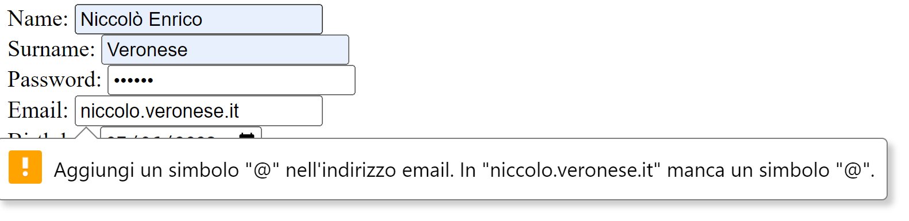

*Result*

The code shows good robustness with respect to wrong emails.

* + 1. **Test Case 3: Account with the same email address of another user**

*Goal*

To guarantee that two user do not have the same email address

*Input*

Email address: [gianluca99.giacomelli@gmail.com](mailto:gianluca99.giacomelli@gmail.com) (already existing)

*Expected output*

Validation error: "the given email is already registered"

*Actual output*

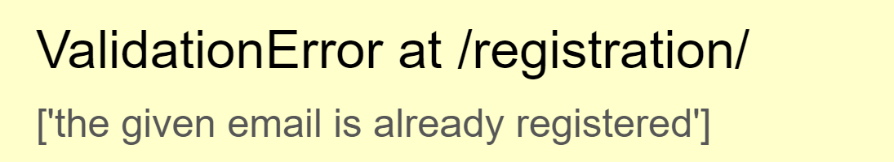

*Result*

The Iqueue prevents users to register with an already existing email

Overall results (Account Registration)

The registration component is robust with respect to many wrong input parameters from the users such as a birthday date which is in the future, a wrong email address or even worse an email address which is already used.

Author

Niccolò Veronese

# Test set: **Shop registration**

Software tested

**Iqueue – Shop view**

Version

Latest

Goal

To show that the registration shop code is robust with respect to different inputs from the users.

* + 1. **Test Case 1: opening time after the closing time**

*Goal*

To show that the shop registration code will not allow to insert an invalid opening time

*Input*

Opening time 09:00 and Closing time 08:00

*Expected output*

“The opening time must be before the closing time”

*Actual output*

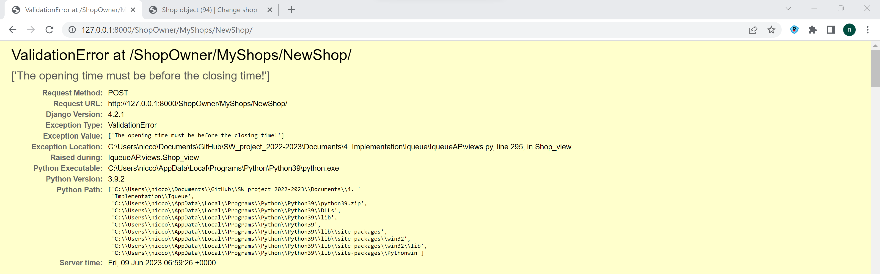

*Result*

The code is robust with respect to a user who tries to put a wrong opening/closing time

* + 1. **Test Case 2: Negative max number of clients**

*Goal*

To prove that the system will not allow to put a negative max number of clients

*Input*

Max number = -2

*Expected output*

The code will not allow to enter a negative number

*Actual output*

The code do not write the minus symbol and it doesn’t allow to go below zero with the arrow of the button

*Result*

The code shows good robustness with respect to negative number of clients.

* + 1. **Test Case 3: Negative slot durations**

*Goal*

To guarantee that the shop owner must not enter a negative slot duration

*Input*

Negative slot duration

*Expected output*

The code does not write negative numbers

*Actual output*

The code does not write negative numbers in that field

*Result*

The Iqueue prevents users to register the shops with a negative slot duration

Overall results (Shop registration)

The shop registration component is robust with respect to many wrong input parameters from the users such as a opening time which is after the closing time, negatives max numbers of clients and negatives time slots.

Author

Niccolò Veronese

# Test set: **Booking and qr code reading**

Software tested

**Iqueue – Booking view, qr view**

Version

Latest

Goal

To show that the booking and the qr reading code is robust with respect to different inputs from the users.

* + 1. **Test Case 1: scan of an already used qr code**

*Goal*

To show that the Iqueue app will not allow to scan two times the same qr code

*Input*

Qr code already used

*Expected output*

Impossible to scan the Qr code

*Actual output*

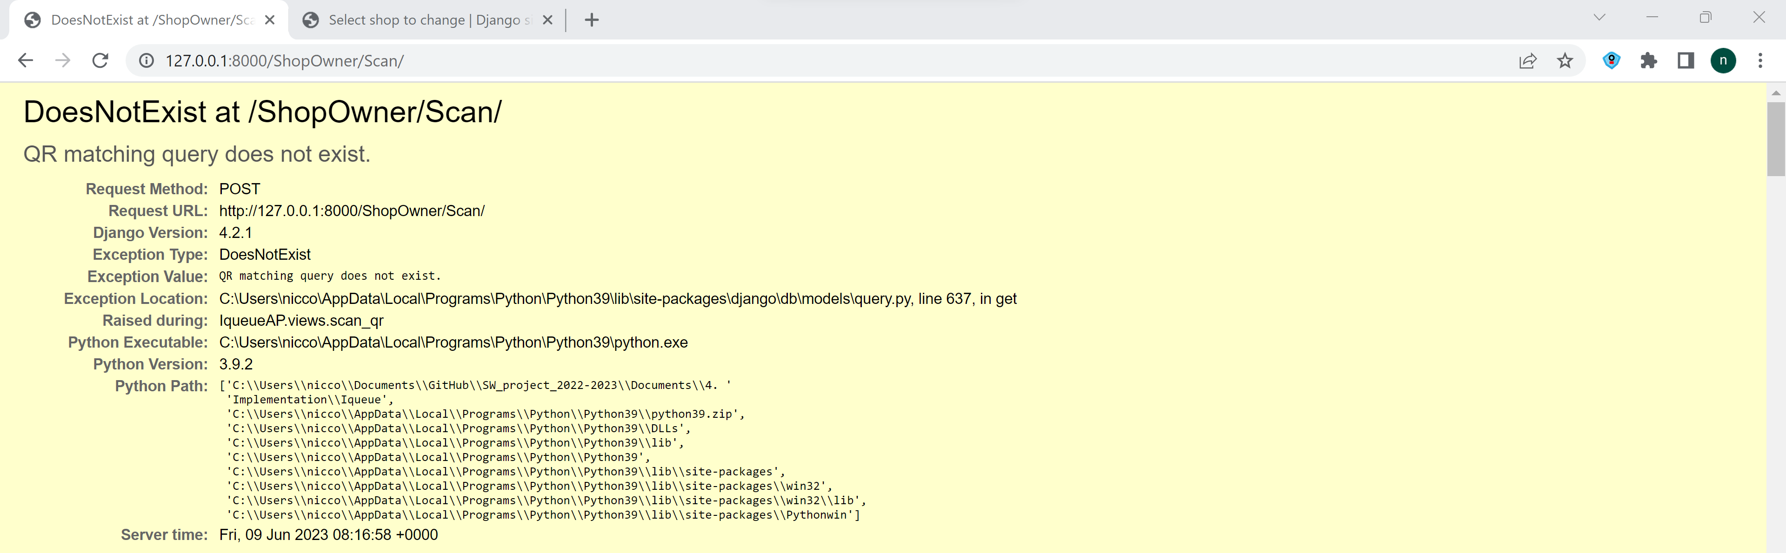

*Result*

The code will not allow to scan two times the same Qr code

* + 1. **Test Case 2: Selection of a time slot in the past**

*Goal*

To prove that the system will not allow to book a passed time slot

*Input*

Time slot in the past: 31/05/2023

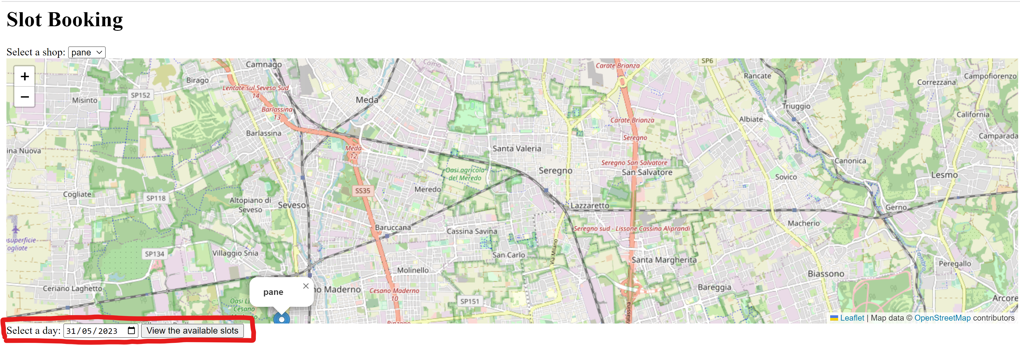

*Expected output*

The code will not allow to book a time slot in the past

*Actual output*

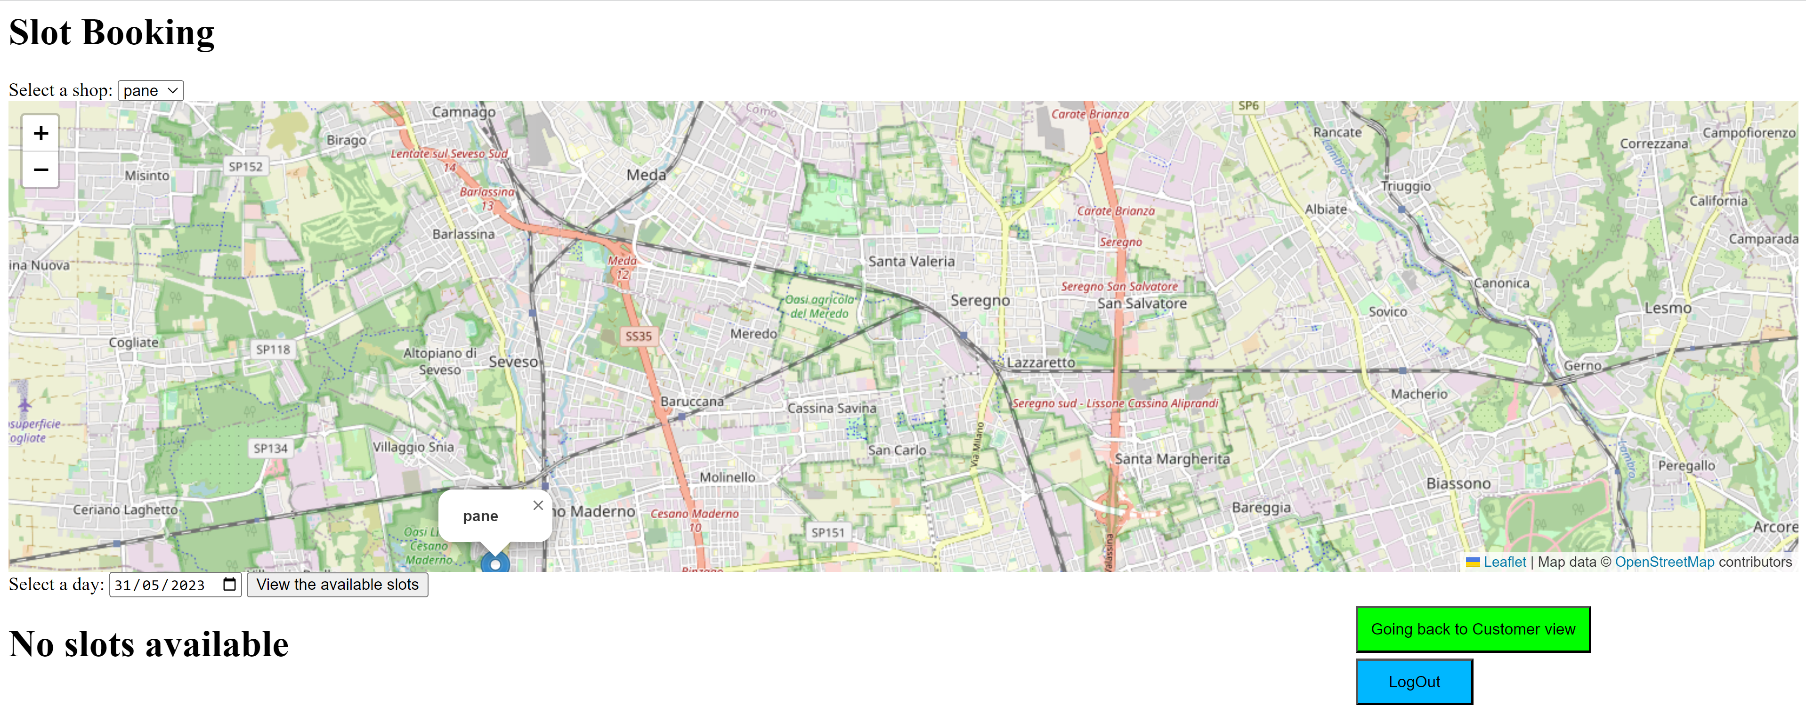

*Result*

The code shows good robustness with respect to slots in the past since it shows that no slots are available for that date.

* + 1. **Test Case 3: Slots too far in the future**

*Goal*

To guarantee that the customer cannot book a slot more than one year in advance

*Input*

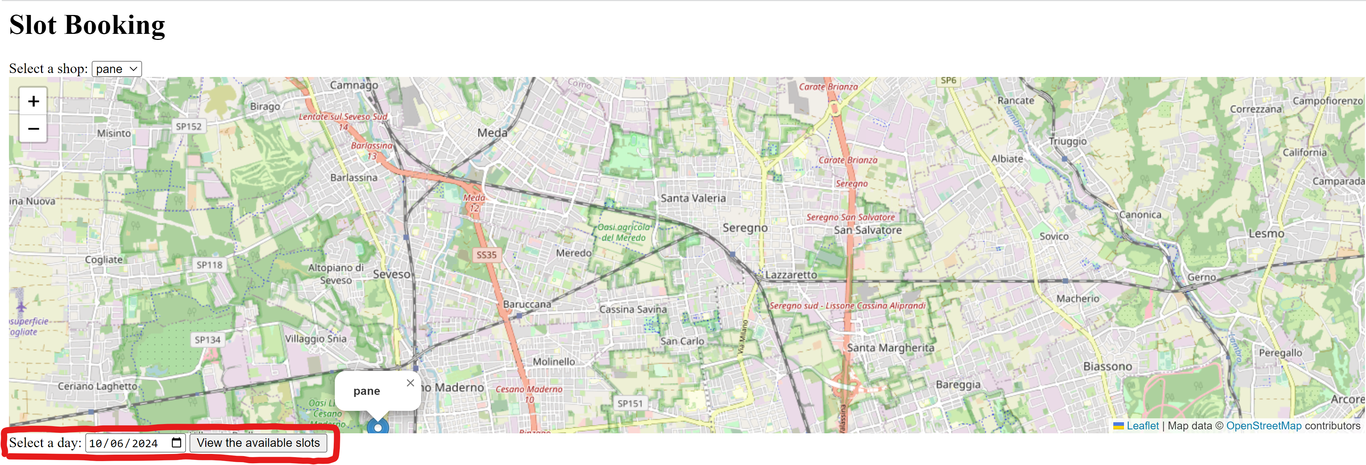

*Expected output*

The code will not show the available slots

*Actual output*

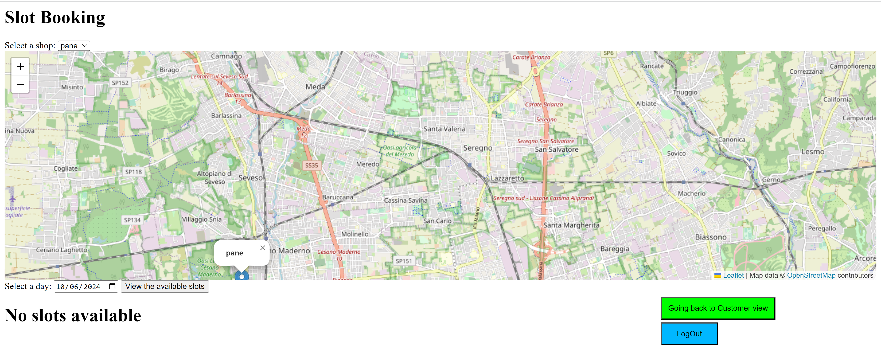*Result*

The Iqueue prevents users to book a slot that is more than one year in advance

Overall results (Booking and qr code reading)

The shop registration component is robust with respect to many wrong input parameters from the users such as a opening time which is after the closing time, negatives max numbers of clients and negatives time slots.

Author

Niccolò Veronese

FRATE, USA IL TEMPLATE SU

# Test set: **Queue (devo ancora finirlo)**

* 1. Software tested

**Iqueue – Booking view, qr view**

* 1. Version

Latest

* 1. Goal

To show that the booking and the qr reading code is robust with respect to different inputs from the users.

* 1. Test case
     1. **Case 1: scan of an already used qr code**
        1. Goal

To show that the Iqueue app will not allow to scan two times the same qr code

* + - 1. Input

Qr code already used

* + - 1. Expected output

Impossible to scan the Qr code

* + - 1. Actual output



* + - 1. Result

The code will not allow to scan two times the same Qr code

* + 1. **Case 2: Selection of a time slot in the past**
       1. Goal

To prove that the system will not allow to book a passed time slot

* + - 1. Input

Time slot in the past: 31/05/2023



* + - 1. Expected output

The code will not allow to book a time slot in the past

* + - 1. Actual output



* + - 1. Result

The code shows good robustness with respect to slots in the past since it shows that no slots are available for that date.

* + 1. **Case 3: Slots too far in the future** 
       1. Goal

To guarantee that the customer cannot book a slot more than one year in advance

* + - 1. Input



* + - 1. Expected output

The code will not show the available slots

* + - 1. Actual output



* + - 1. Result

The Iqueue prevents users to book a slot that is more than one year in advance

* 1. Overall results

The shop registration component is robust with respect to many wrong input parameters from the users such as a opening time which is after the closing time, negatives max numbers of clients and negatives time slots.

* 1. Author

Niccolò Veronese

Test da fare:

white box per:

prenotazione

creazione advertisement

black box per:

qr reading

iscrizione account

iscrizione nuovi shop

iscrizione nuovi prodotti

lista persone in attesa